AI ASSISTED CODING ASSIGNMENT – 6.3
N. SATHWIK (2303A51032)
BATCH-01

Task Description #1 (Loops – Automorphic Numbers in a Range)
Task: Prompt AI to generate a function that displays all Automorphic numbers between 1 and 1000 using a for loop.
• Instructions:
- Get AI-generated code to list Automorphic numbers using a for loop.
- Analyse the correctness and efficiency of the generated logic.
- Ask AI to regenerate using a while loop and compare both implementations.
Expected Output #1:
• Correct implementation that lists Automorphic numbers using both loop types, with explanation.

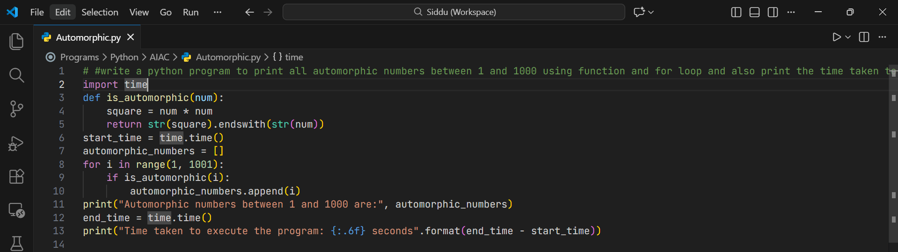
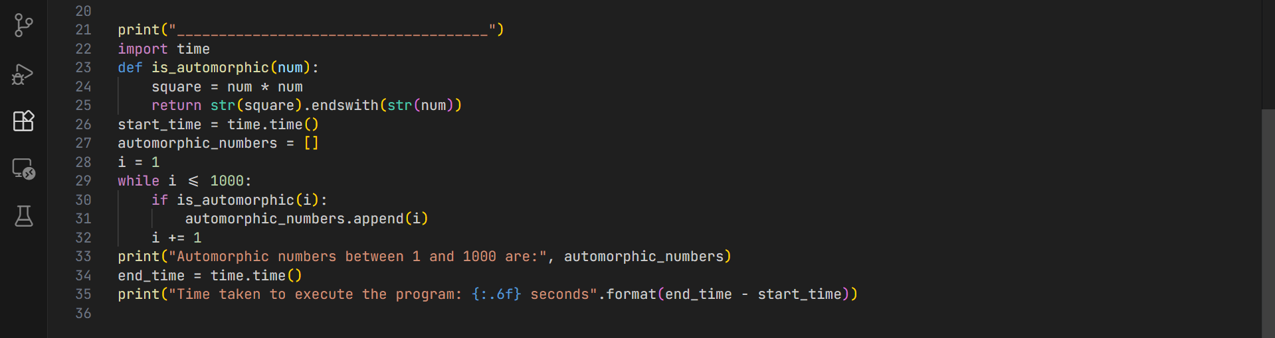
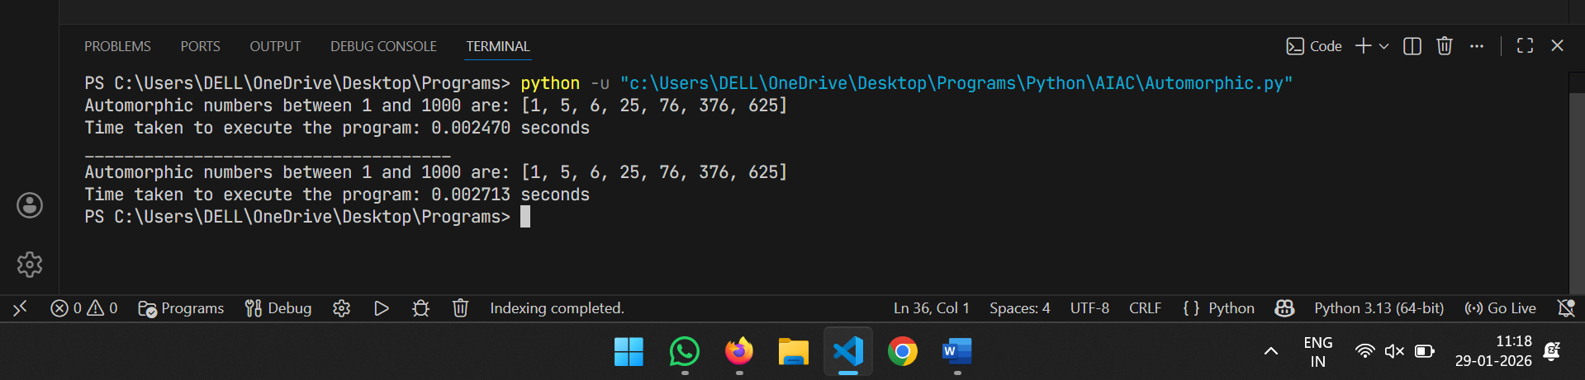
Explanation:
FOR LOOP (First Implementation):
for i in range(1, 1001):
if is_automorphic(i):
automorphic_numbers.append(i)

Characteristics:
- Automatic iteration: range(1, 1001) automatically generates numbers 1 to 1000
- Counter management: Python handles the counter (i) incrementing automatically
- Concise: Less code, fewer lines
- Less error-prone: No risk of forgetting to increment the counter or creating infinite loops
- Pythonic: This is the preferred Python style for counting iterations

WHILE LOOP (Second Implementation):
i = 1
while i <= 1000:
if is_automorphic(i):
automorphic_numbers.append(i)
i += 1

Characteristics:
- Manual iteration: You must initialize i = 1 before the loop
- Manual counter management: You must remember to increment i += 1 at the end
- More verbose: Requires 3 extra lines of setup/management
- More error-prone: Forgetting i += 1 creates an infinite loop
- Flexibility: Better when the increment pattern is complex or conditional

WHY THE DIFFERENCE?
Both loops produce identical results and have nearly identical performance for this use case.

Key Differences:
- Readability: The for loop is cleaner and more readable
- Safety: The for loop eliminates the risk of infinite loops
- Intent: for loop clearly shows "iterate 1000 times", while while loop focuses on the condition

Task Description #2 (Conditional Statements – Online Shopping Feedback
Classification)
Task: Ask AI to write nested if-elif-else conditions to classify online shopping feedback as Positive, Neutral, or Negative based on a numerical rating (1–5)
• Instructions:
- Generate initial code using nested if-elif-else.
- Analyze correctness and readability.
- Ask AI to rewrite using dictionary-based or match-case structure.
Expected Output #2:
• Feedback classification function with explanation and an alternative approach.
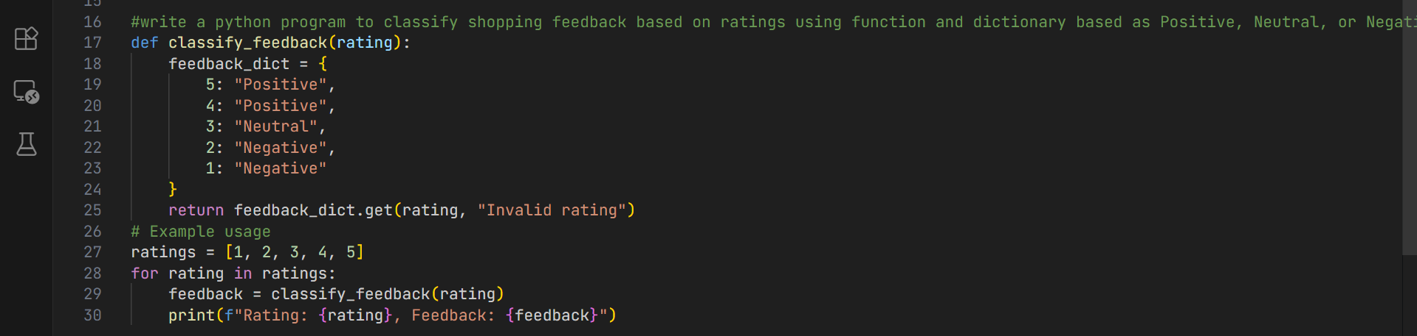
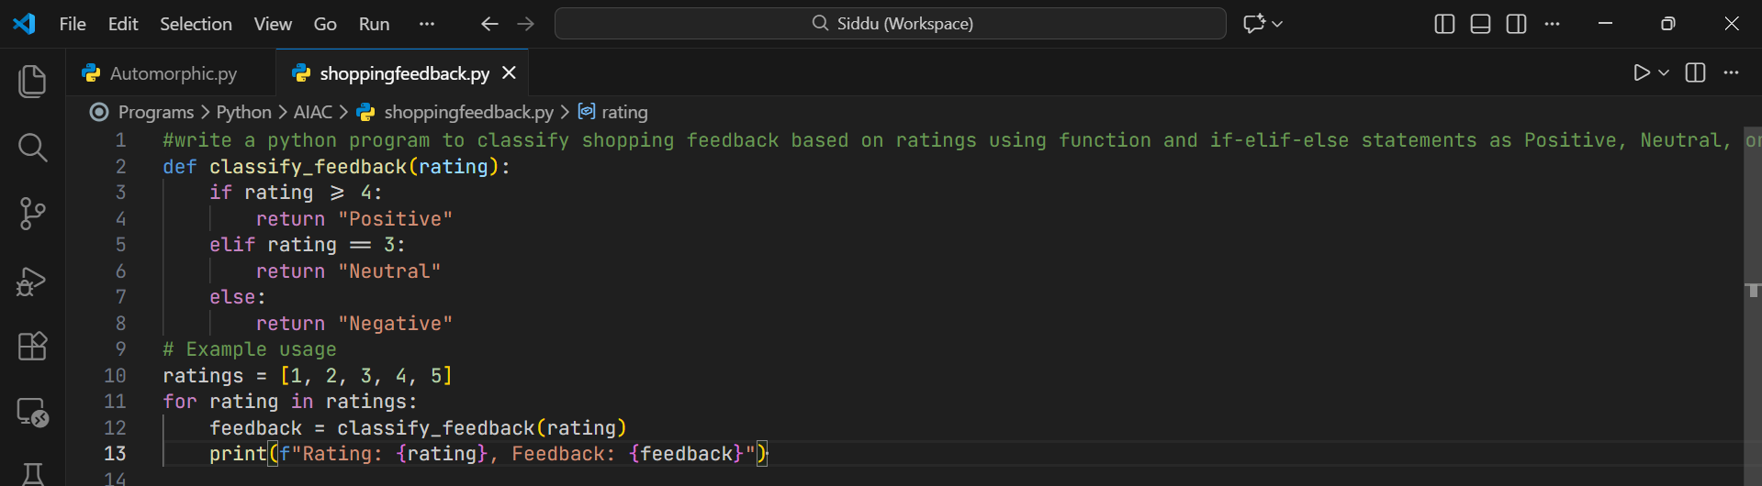
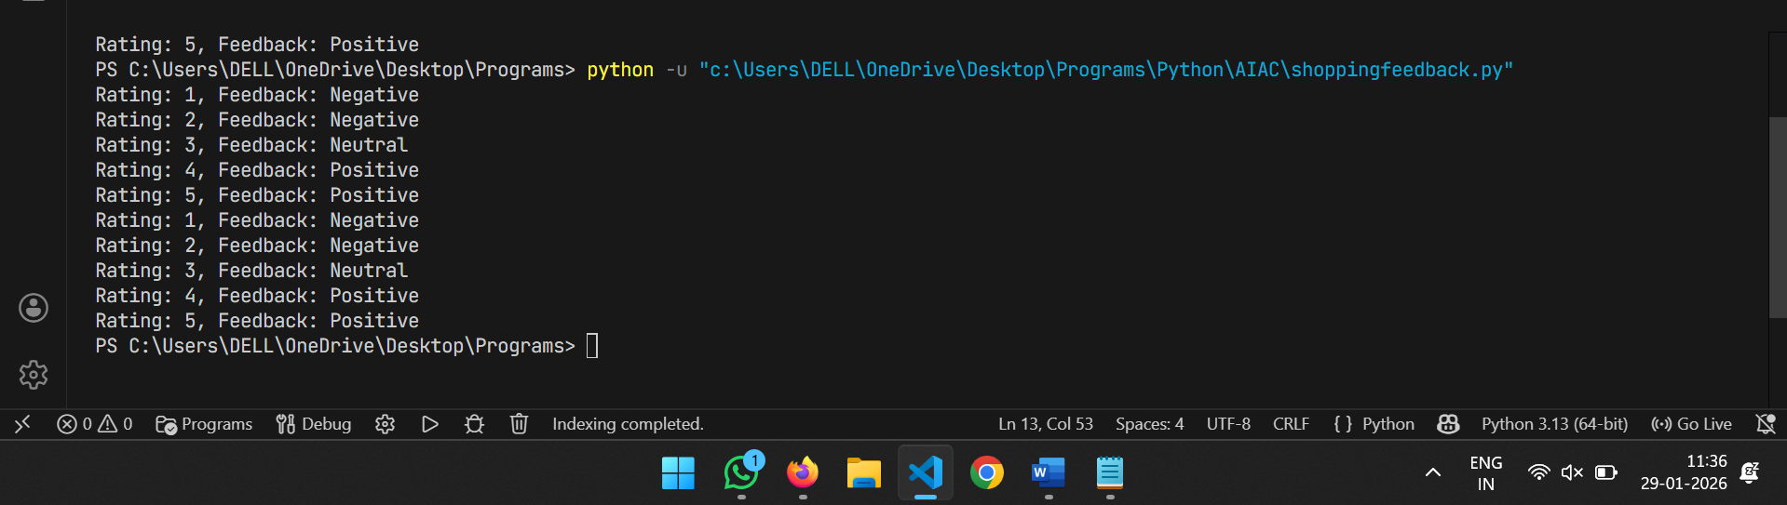
Task Description #3 Statistical_operations
Task: Define a function named statistical_operations(tuple_num) that performs the following statistical operations on a tuple of numbers:
- Minimum, Maximum
- Mean, Median, Mode
- Variance, Standard Deviation
While writing the function, observe the code suggestions provided by GitHub Copilot. Make decisions to accept, reject, or modify the suggestions based on their relevance and correctness.
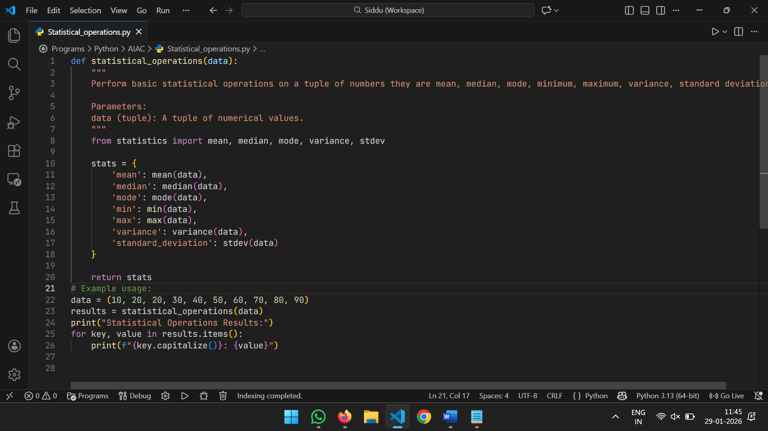
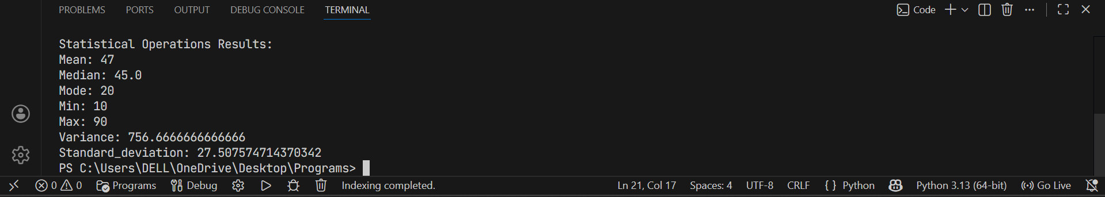

Task Description #4 Teacher Profile
Prompt: Create a class Teacher with attributes teacher_id, name, subject, and experience. Add a method to display teacher details.
Expected Output #4:
• Class with initializer, method, and object creation.
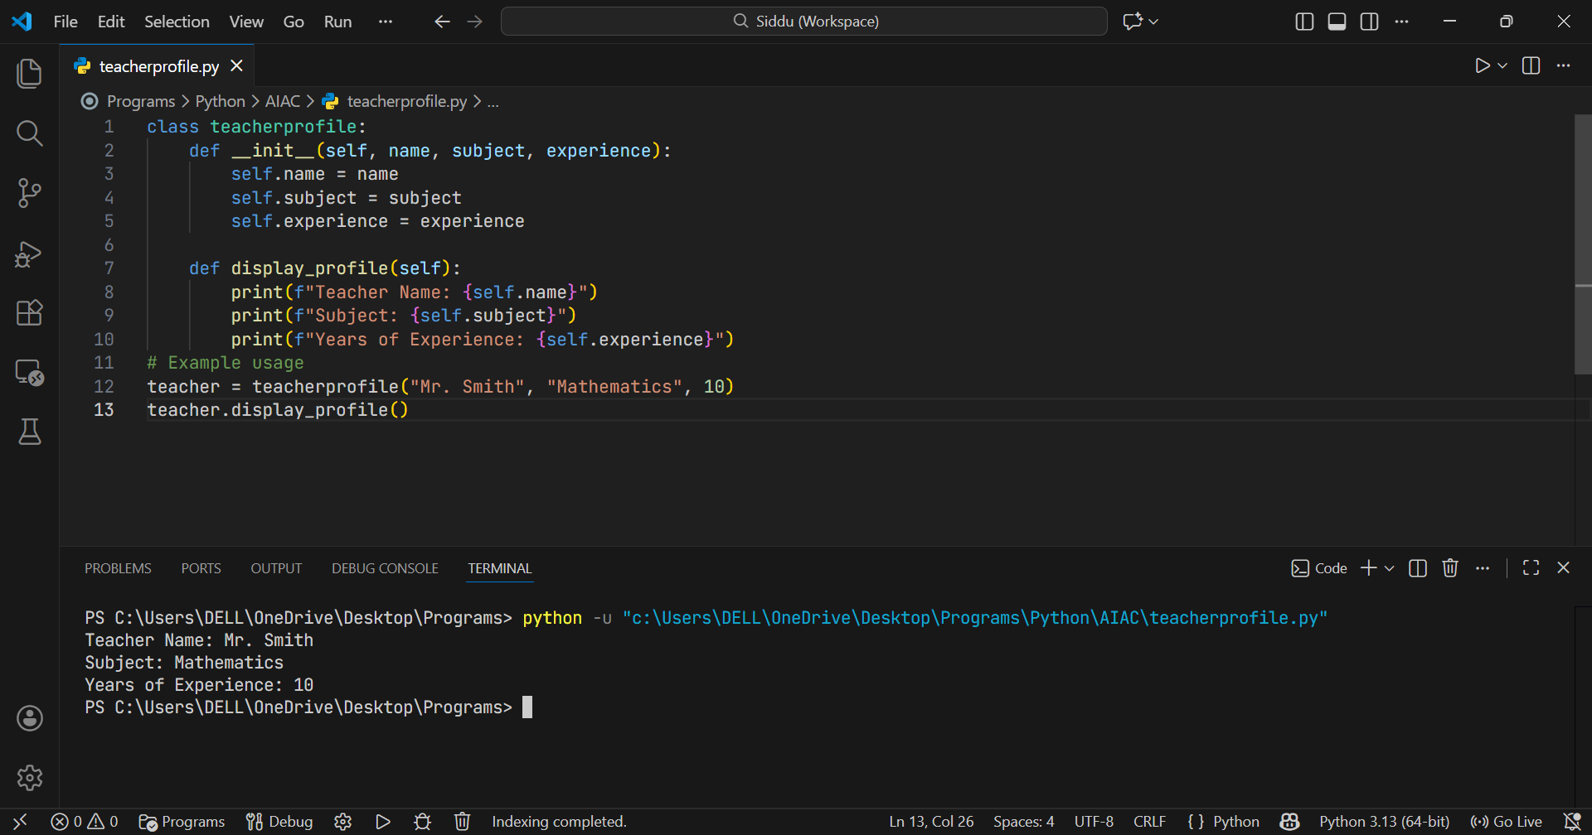

Task Description #5 Zero-Shot Prompting with Conditional Validation
Task: Use zero-shot prompting to instruct an AI tool to generate a function that validates an Indian mobile number.
Requirements
- The function must ensure the mobile number:
- Starts with 6, 7, 8, or 9
- Contains exactly 10 digits

Expected Output #5:
• A valid Python function that performs all required validations without using any input-output examples in the prompt.
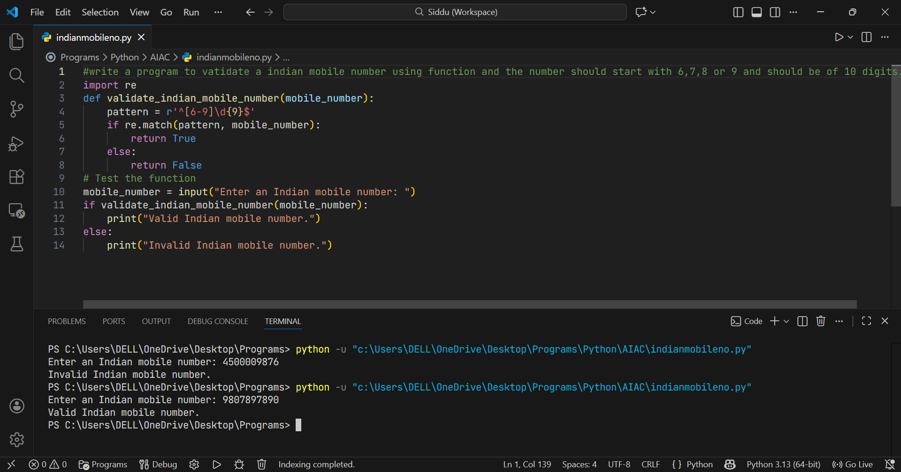
Task Description #6 (Loops – Armstrong Numbers in a Range)
Task: Write a function using AI that finds all Armstrong numbers in a user-specified range (e.g., 1 to 1000).
• Instructions:
- Use a for loop and digit power logic.
- Validate correctness by checking known Armstrong numbers (153, 370, etc.).
- Ask AI to regenerate an optimized version (using list comprehensions).
Expected Output #6:
• Python program listing Armstrong numbers in the range.
• Optimized version with explanation.

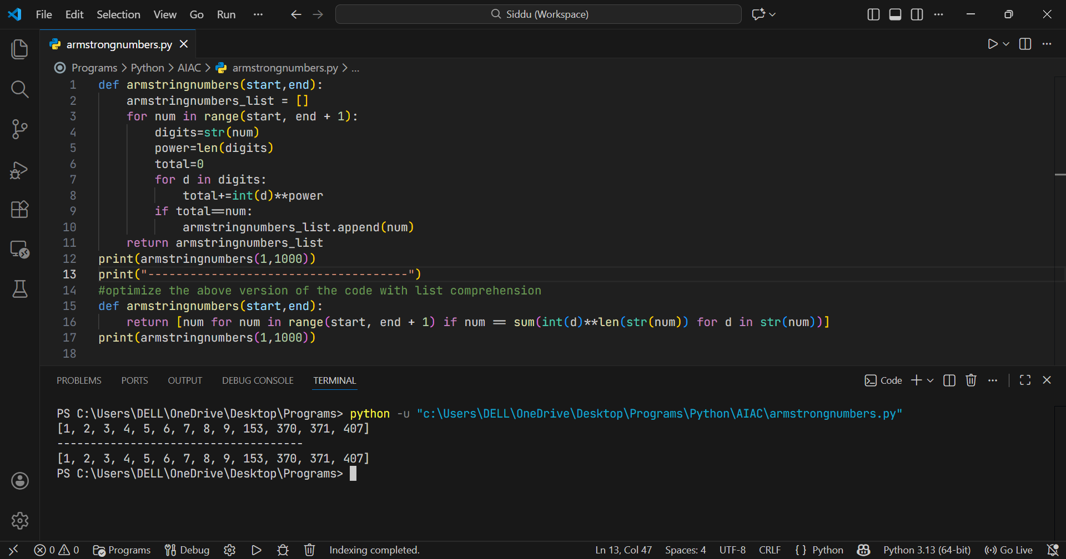

Task Description #7 (Loops – Happy Numbers in a Range)
Task: Generate a function using AI that displays all Happy Numbers within a user-specified range (e.g., 1 to 500).
• Instructions:
- Implement the logic using a loop: repeatedly replace a number with the sum of the squares of its digits until the result is either 1 (Happy Number) or enters a cycle (Not Happy).
- Validate correctness by checking known Happy Numbers (e.g., 1, 7, 10, 13, 19, 23, 28…).
- Ask AI to regenerate an optimized version (e.g., by using a set to detect cycles instead of infinite loops).

Expected Output #7:
• Python program that prints all Happy Numbers within a range.
• Optimized version using cycle detection with explanation.
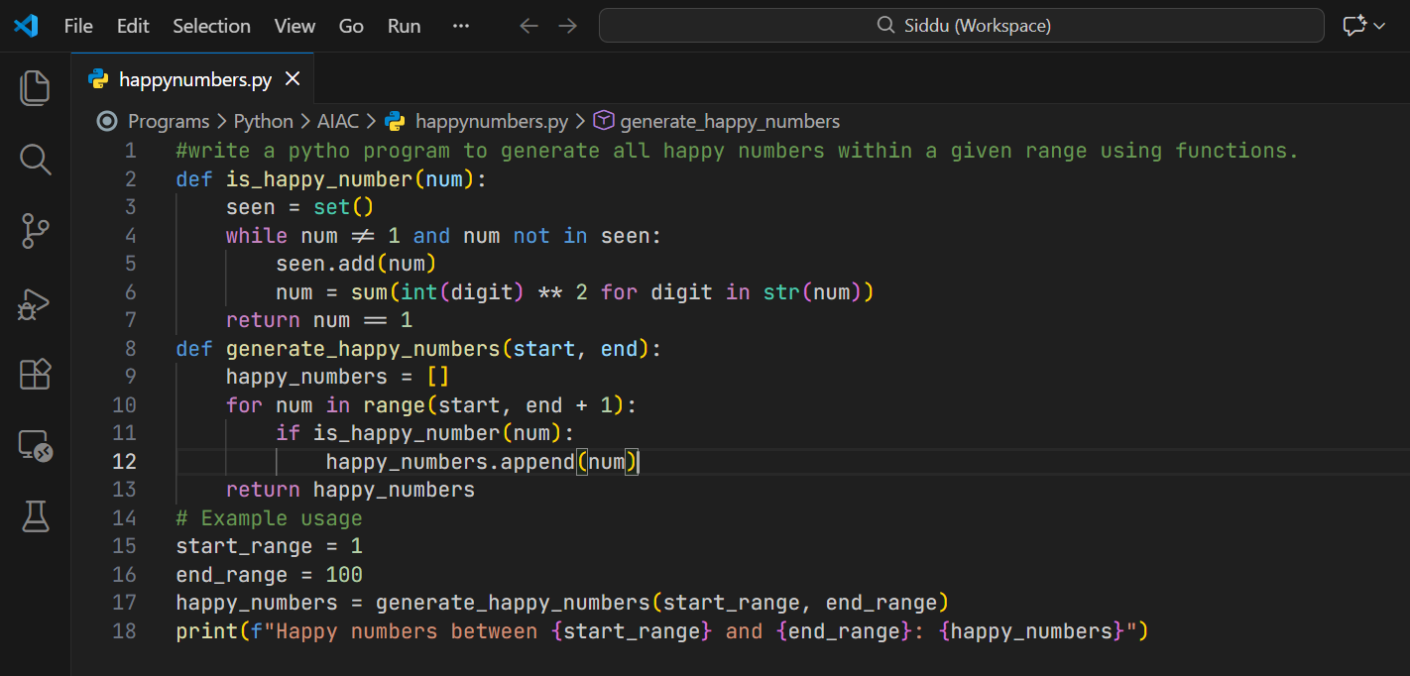
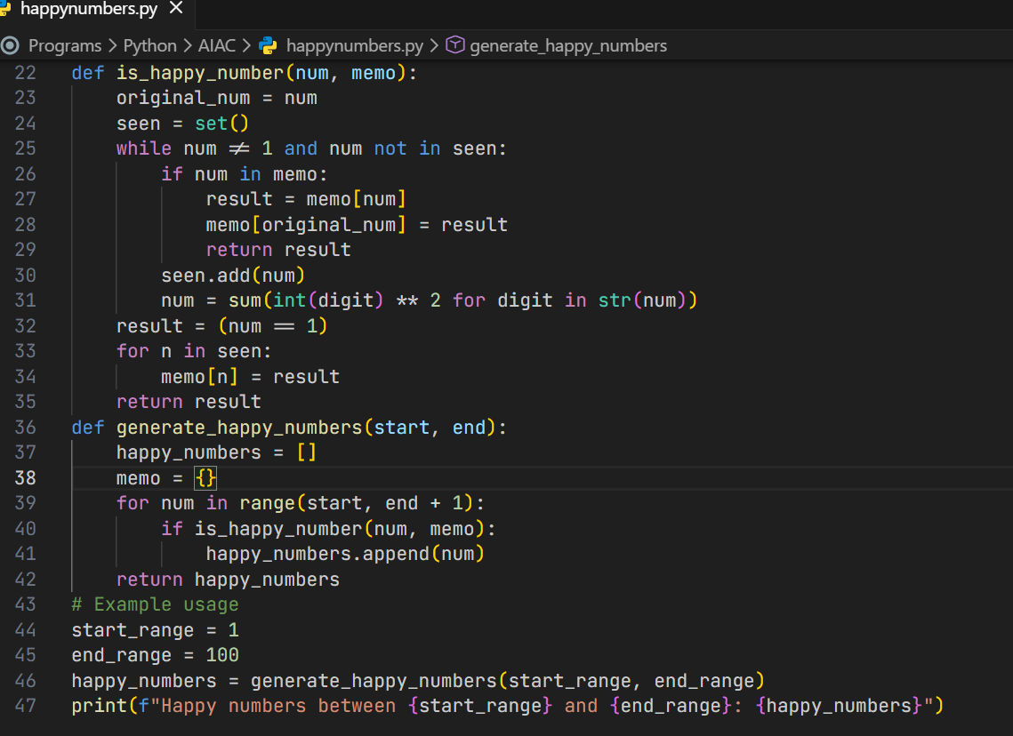
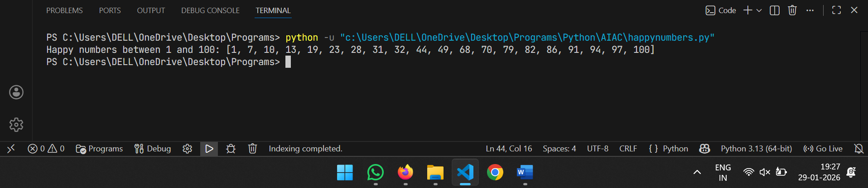
Task Description #8 (Loops – Strong Numbers in a Range)
Task: Generate a function using AI that displays all Strong Numbers (sum of factorial of digits equals the number, e.g., 145 = 1! +4! +5!) within a given range.
• Instructions:
- Use loops to extract digits and calculate factorials.
- Validate with examples (1, 2, 145).
- Ask AI to regenerate an optimized version (precompute digit factorials)
Expected Output #8:
• Python program that lists Strong Numbers.
• Optimized version with explanation.
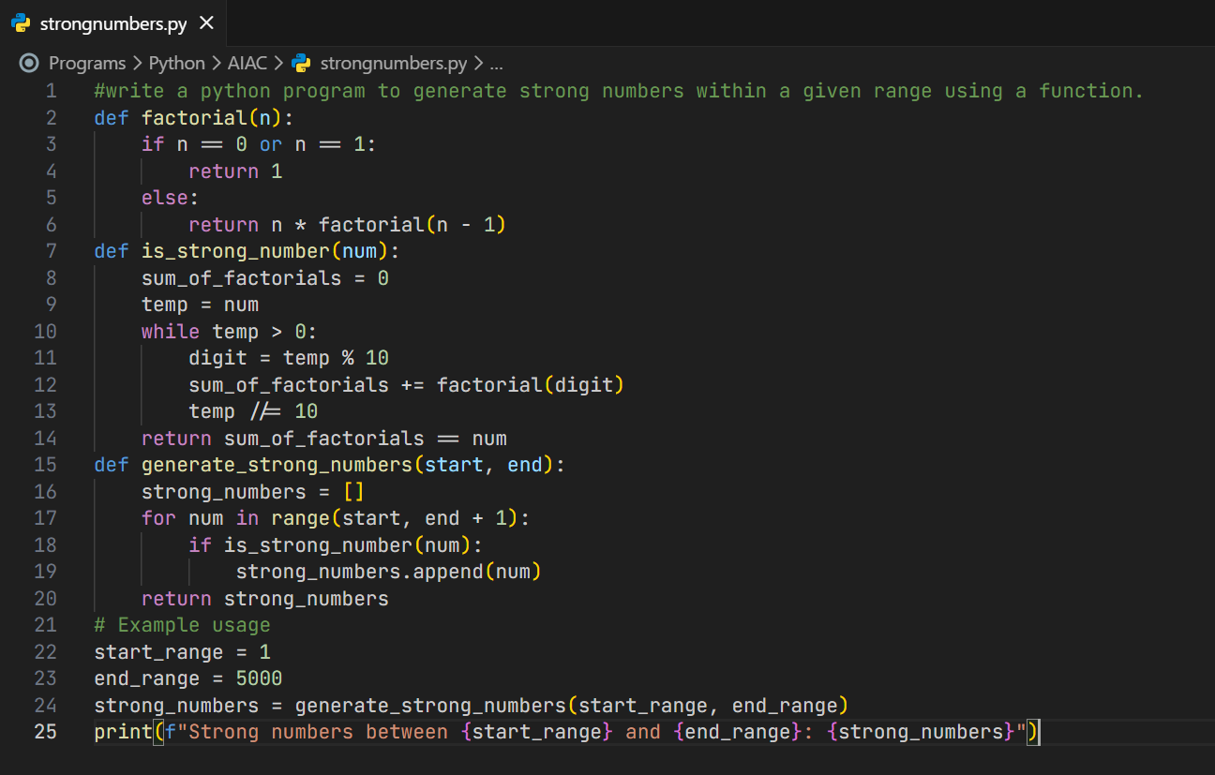
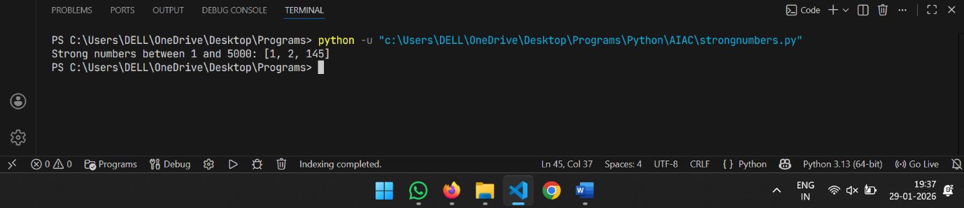
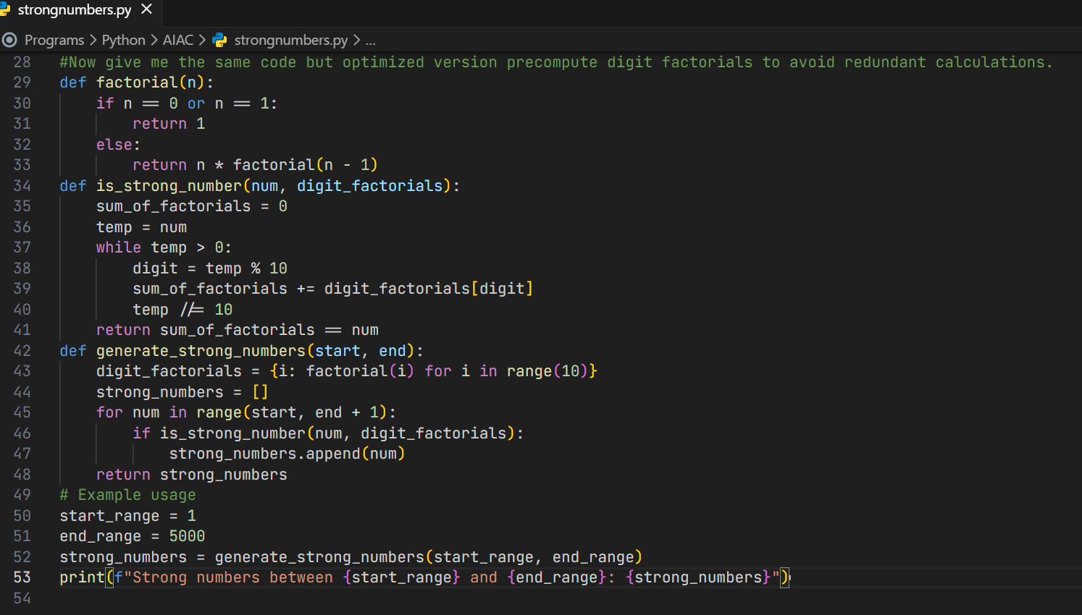
Task Description #9 Few-Shot Prompting for Nested Dictionary Extraction
Task: Use few-shot prompting (2–3 examples) to instruct the AI to create a function that parses a nested dictionary representing student information.
• Requirements:
- The function should extract and return:
- Full Name
- Branch
- SGPA
Expected Output #9:
A reusable Python function that correctly navigates and extracts values from nested dictionaries based on the provided examples.
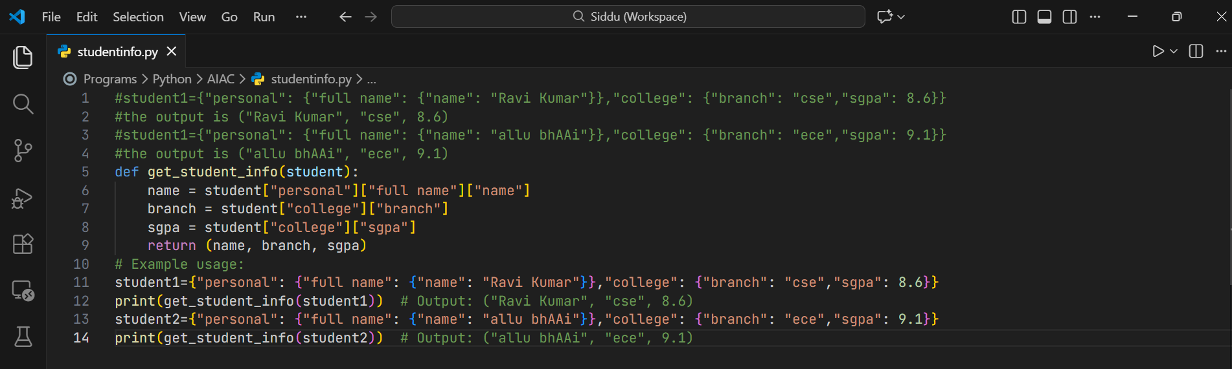
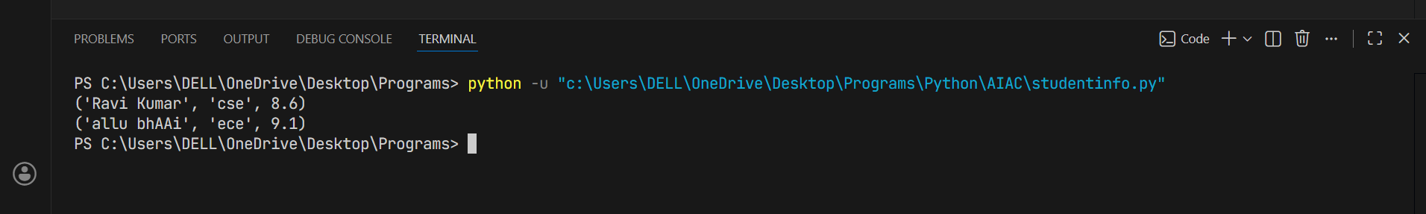
Task Description #10 (Loops – Perfect Numbers in a Range)
Task: Generate a function using AI that displays all Perfect Numbers within a user-specified range (e.g., 1 to 1000).
• Instructions:
- A Perfect Number is a positive integer equal to the sum of its proper divisors (excluding itself).
- Example: 6 = 1 + 2 + 3, 28 = 1 + 2 + 4 + 7 + 14.
- Use a for loop to find divisors of each number in the range.
- Validate correctness with known Perfect Numbers (6, 28, 496…).
- Ask AI to regenerate an optimized version (using divisor check only up to √n).
Expected Output #10:
• Python program that lists Perfect Numbers in the given range.
• Optimized version with explanation.
